User Roles and Rules for the PRMS Reporting Tool
Roles:
Roles define the level of responsibility and permissions a user can have within the PRMS. They determine the role a user has in the submission of results and data management within PRMS, ensuring consistent governance, accountability, and clarity of access across Portfolio (or reporting entities – whichever version you plan to use from now on).
Lead and Co-Lead:
The Lead and the Co-Lead have similar responsibilities and they are accountable and responsible for validating and managing submissions in PRMS. He/She can:
- Create, edit, or delete results for their Science Program/Accelerator and/or project(s).
- Review and accept/reject contributions submitted by other Science Program/Accelerator and/or project(s)
- Submit or unsubmit results for their Science Program/Accelerator and/or project(s).
- Update and maintain results throughout the reporting cycle.
- Full access to the Admin module.
Coordinator:
The Coordinator provides oversight of submissions and data management in PRMS, ensuring alignment with reporting requirements and timelines. A Coordinator can act on behalf of a Lead or Co-Lead when necessary, ensuring business continuity and accountability in the reporting process.
Member**:**
The Member contributes to PRMS by creating, editing, updating results within their Science Program/Accelerator and/or project(s). Members do not have the authority to submit, unsubmit, approve, or manage results after submission.
Admin
The Admin role provides full oversight and control across all Science Programs, Accelerators, and projects within the system. Unlike Leads and Co-Leads, who act only on behalf of their specific Science Program, Accelerator, or project, Admins ensure centralized governance and system-wide consistency. They are responsible for maintaining alignment, safeguarding data integrity, and supporting or intervening across the portfolio when needed.
Guest
Users assigned to the Guest role will only have read-only access to the platform and will not be able to perform any other actions beyond viewing information.
User Role Rules
The following rules define how roles are assigned and managed within Science Programs and Accelerators. They ensure consistency, prevent conflicts in leadership assignments, and clarify the permissions available for CGIAR Network users and external users.
- A user can only have one role per entity (Science Program/Accelerator).
- Any individual with a CGIAR email address may be assigned to any PRMS user role (Lead, Co-Lead, Coordinator, or Member). Role assignments are processed upon request to PPU/PCU via *performanceandresults@cgiar.org .*
- External (non-CGIAR) users may only be assigned the Member role within a specific Science Program/ Accelerator and/or project.
- Each Science Program/ Accelerator can have only one Lead.
- Each Science Program/Accelerator can have only one Co-Lead.
- Each Science Program/Accelerator can have multiple Coordinators and multiple Members as needed.
- If an Admin assigns a new Lead or Co-Lead where one already exists, the system will reassign the current Lead/Co-Lead to Coordinator and assign the new user as the Lead or Co-Lead accordingly.
Active and Inactive User:
The user who beind inactive won’t have access to the reporting unless the Admin assign a new role within a Science Program/Accelerator. The plaforms provides the option to Inactive the user by using the option Inactive (see image.)
- Inactive Users
  - Inactive users will not have access to reporting tool unless the Admin assigns them a new role within a Science Program or Accelerator.
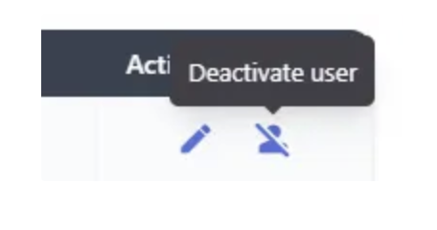
  - The platform provides an option to deactivate a user by selecting Inactive (see image).

- Active Users
  - To activate a user, simply use the Active option and assing new role for the user.
